Factors Affecting Management Plan in Cases with Unilateral Vestibular Schwannoma
Abstract:
Background: In adults, eighty-five percent of tumors in the cerebellopontine angle are vestibular schwannomas (VS), which can lead to hearing loss, balance issues, and tinnitus. Advances in diagnostic and surgical techniques have reduced their recurrence rates to less than 1%. However, optimal management remains a challenge, requiring tailored approaches based on tumor characteristics and patient factors. This research aimed to assess the factors influencing management decisions for unilateral vestibular schwannoma, including tumor size, location, patient age, and hearing condition. Methods: This prospective trail involved 30 individuals with unilateral VS treated at Benha University Hospital and International Medical Center. Patients underwent observation, Gamma Knife radiosurgery (GKRS), microsurgery, or a combination approach, with a minimum follow-up of 6 months. Results: The average age of participants was 41 years, with 73.3% undergoing surgical treatment and 70% receiving GKRS. Among GKRS patients, 47.6% received it preoperatively, and 52.4% postoperatively. Tumor progression led to a shift from conservative to active treatment in 72.7% of cases. Postoperative complications included facial nerve palsy (14.3%), edema (9.5%), and cerebrospinal fluid leaks (4.5%). Tumor regrowth was observed in 14.3% of patients treated with GKRS. Conclusion: Management of unilateral VS is influenced by tumor size, location, and patient-specific factors. While conservative management can be effective, progression often necessitates GKRS or surgical intervention. A tailored approach based on these factors optimizes outcomes for patients.
Keywords: Vestibular schwannoma; Gamma Knife radiosurgery; microsurgery; hearing loss; cerebellopontine angle.
Introduction:
The vestibular ganglion is the site of origin for vestibular Schwannomas. Located inside the IAC In adults, 85 percent of cerebellopontine angle tumors are vestibular schwannomas, which primarily affect the inferior division of the vestibular branch of cranial nerve VIII (91.4 percent of cases) as well as to a lesser degree, the superior division (6 percent of cases) ⁽¹⁾.
Normal symptoms of a tumor include hearing loss, imbalance, as well as tinnitus. Nonetheless, paresis, facial numbness, discomfort, or headache are all possible side effects. Due to advancements in both early detection and surgical methods, the recurrence rate of vestibular schwannomas is now often below one percent ⁽²⁾.
The intraoperative neurophysiological monitoring was a safe and widely available option in microsurgery ⁽³⁾.
It is only by utilizing the retro sigmoid and middle cranial fossa techniques that hearing preservation may be accomplished. Headache, cerebrospinal fluid leak, meningitis, facial nerve paralysis, damage to the auditory nerve, and vascular injury are some of the early postoperative problems. Delayed problems, such as atrophy of the cerebellar or temporal lobes or postoperative hearing loss, are conceivable. A return of tumors, labyrinthitis (with or without labyrinthine ossification), microvascular damage to the cochlea, or a fenestration in the bone labyrinth are all potential causes of hearing loss after a hearing preservation procedure ⁽⁴⁾.
Stereotactic radiosurgery is an additional therapeutic option; it involves precisely targeting the tumor's shape and location with a single fraction of radiation dosage using a gamma knife or linear accelerator. Stereotactic radiosurgery can cause oedema in the surrounding brain, tinnitus, problems with balance, and hydrocephalus, which affects one percent to 13 percent of individuals and requires intervention ⁽⁵⁾.
This research aimed to assess the factors affecting the decision of management plan for cases with unilateral vestibular schwannoma. These factors are tumor size, location, age of the patients and hearing condition.
Patients and methods:
Patients:
This prospective research was carried out at Benha neurosurgery department at Benha university hospital and international medical center (neurosurgery department and gamma knife department). Thirty patients with vestibular schwannoma were subjected to one or more of the different treatment’s modalities, and to follow up period not less than 6 months spanned from December 2021 till December 2023.
Informed written consent was acquired from the participants. Each participant was provided with an explanation of the study's objective and assigned a confidential code number. The study was conducted with approval from the Research Ethics Committee of the Faculty of Medicine, Benha University {M.D.2.1.2022}.
Inclusion criteria were patients with radiologically and histopathologically confirmed unilateral vestibular schwannoma, a well-documented surgical approach, and a minimum follow-up period of 6 months.
Exclusion criteria were refusal to participate, patients with neurofibromatosis type 2, recurrent vestibular schwannoma, other intracranial space-occupying lesions, or any life-threatening conditions that could influence treatment decisions or the follow-up period.
Methods:
All examined individuals underwent the following procedures: Detailed history taking, involving [Personal history; name, gender, age, Present history: course of the disease and duration, Past history of any medical condition or previous hospital admission]. Full clinical examination: General examination and neurological examination and suitable radiological investigations including brain contrasted MRI, C.T brain, and pure tone audiometry.
Patients were treated with one of the different treatment modalities either observational treatment, stereotactic radiosurgery (Gamma knife), microsurgical treatment or even a combined treatment consistent with the treatment algorithm which is based on tumor size, rate of growth, clinical and general condition with consideration patients’ preferences. Microsurgical resections were performed using the retrosigmoid approach, providing a direct path to the tumor. Gamma Knife Radiosurgery (GKRS) was applied as adjuvant therapy for 13 patients and as the initial treatment for 8 patients, utilizing the Gamma Knife ICON model at the International Medical Center.
Before undergoing GKRS, all patients received antiepileptic medication the day before the procedure. They were admitted and discharged on the same day, receiving a single session of GKRS. The procedure involved applying a Leksell frame under light sedation and local anesthesia, followed by a new contrasted MRI scan to guide treatment. Radiation doses ranged from 12 to 15 gray, achieving an average tumor coverage of 98%. Patients were sent home with paracetamol and dexamethasone for two days post-procedure. Follow-up evaluations, including clinical and radiological assessments with contrasted MRI, were conducted at 6 months, 1 year, and upon study closure when the final patient reached 6 months of follow-up. During these visits, patients were also interviewed regarding any symptoms such as unsteadiness, unilateral hearing loss, vertigo, or tinnitus. The final outcomes were based on the last available follow-up data.
Statistical analysis:
Software from IBM (Armonk, New York, USA) called SPSS version 28 was used for data management and statistical analysis. The normality of the quantitative data was checked by utilizing direct data visualization methods and the Shapiro-Wilk test. Quantitative data were summarized using medians and ranges or means and standard deviations in accordance with normality. Numbers and percentages were used to summarize the categorical data. For quantitative variables with normally distributed data, we used the independent t-test; for non-normally distributed data, we used the Mann-Whitney U test. We compared the results by surgical treatment decision as the first line. The Chi-square or Fisher's exact test was used for comparing categorical data. There were no one-sided statistical tests. Significance was determined by p-values below 0.05.
Results:
The study involved 30 participants with an average age of 41 years and a balanced gender distribution. Most participants (83.3%) had left side lesion, while smoking prevalence was low (13.3%), and 23.3% reported chronic illnesses. The majority experienced hearing loss (86.7%), with other symptoms like tinnitus (70%), unsteadiness (50%), and less frequent occurrences of muscle weakness, vertigo, and lower cranial nerve affection. Facial nerve involvement was observed in 40% of cases, and improvement was reported by 56.7% of participants. Table 1
The average tumor size was 3.5 cm, and severity was categorized into Koos Grades III (70%) and IV (30%), with hydrocephalus in 30% of patients. Audiometric assessments showed significant hearing impairment, with 73.3% having a Pure Tone Average (PTA) above 50 decibels. Table 1
In our study of 30 patients, Gamma Knife radiosurgery (GKRS) was used for 70% (21 patients), with 47.6% receiving it preoperatively and 47.6% postoperatively. Among these, 57.1% (12 patients) underwent a combination of GKRS and surgical interventions, The treated target volumes averaged 3.5 cc with a standard deviation of 1.7, and a consistent radiation dose of 12 Gy was applied. The average isodose curve was 47, with a variability of 7, and coverage averaged 98% with a standard deviation of 1. Table 2
Pain at the side of the lesion was reported by all patients treated with GKRS, and headaches affected 95.2% (20 patients). Vasovagal attacks were noted in 23.8% (5 patients). Late side effects included edema in 9.5% (2 patients), with vertigo and tinnitus each affecting 4.8% (1 patient). Facial nerve palsy occurred in 14.3% (3 patients). Table 2
Most patients (73.3%) underwent surgical treatment, with the first-line treatment applied in 36.4% of cases, and all procedures utilized the retro-sigmoid approach. The median maximum tumor diameter was 4 centimeter, ranging from 3 to 6 cm. Preoperative ventriculoperitoneal (V/P) shunt insertion was performed in 45.5% of patients. During surgery, 90.9% were positioned laterally, while 4.5% were positioned sitting or supine. Subtotal tumor removal was achieved in 95.5 percent of cases, with only one patient (4.5%) undergoing a biopsy. Table 3
Intraoperative complications included hemorrhage in 9.1% of patients, cranial nerve injury in 18.2%, and brainstem injury in 4.5%. Postoperatively, there were no cases of hematoma or acute hydrocephalus (HCP), but cerebrospinal fluid (CSF) leaks occurred in 4.5%, and wound infections in 9.1%. The median ICU stay was 3 days (range: 1-7 days), and the median hospital stay was 7 days (range: 0-14 days). Additionally, 4.5% of patients required redo surgery. For those treated with Gamma Knife radiosurgery, the median follow-up duration was 3 years, with a range of 1 to 8 years, during which tumor regrowth occurred in 14.3% of cases (3 patients). Table 3
participants were classified into 2 groups: those who underwent surgery as the first line of treatment and those who did not, or who underwent surgery but not as the first line. No significant variations were found among the groups concerning age, gender distribution, hemisphere dominance, smoking status, presence of chronic illnesses, symptom duration, or initial complaints. Both groups had 100% prevalence of gradual sensorineural hearing loss (SNHL). The occurrence of tinnitus, unsteadiness, weakness, vertigo, and facial nerve affection. There were also no significant distinctions in the proportions of cases experiencing clinical deterioration or improvement, trigeminal nerve affection, or lower cranial nerve affection. Table 4
Additionally, the largest dimension of the lesions. Koos grading and the presence of hydrocephalus (HCP) were similar across the groups. Audiometric measures, including pure-tone average (PTA), speech recognition threshold (SRT), speech detection threshold (SDT), and word discrimination scores, did not differ significantly between the groups. Thus, the choice of surgical timing did not seem to influence these clinical and diagnostic variables. Table 4
Case 1
Female patient 38 years old presented to us with loss of hearing in right ear since 2 months with gradual onset progressive course also complained of tinnitus. On examination the patient is conscious and alert with hearing loss in right ear. MRI brain with contrast showed right CPA vestibular schwannoma. Audiogram revealed right SNHL. The patient was advised to do surgery but she preferred to do gamma knife radiosurgery from the start. Figure 1(A, B and c)
Case2
Female patient 70 years old presented to us with right trigeminal pain, unsteadiness of gait and loss of hearing in right ear. On examination the patient is conscious and alert, right diminished hearing and unsteadiness of gait. MRI brain with contrast showed right CPA vestibular schwannoma. Audiogram revealed right SNHL. The patient was treated with gamma knife radiosurgery. Figure 2(A and B)
Case 3
Male patient 50 years old presented to us with loss of hearing in left ear. On examination the patient is conscious and alert, left diminished hearing. MRI brain with contrast showed left CPA vestibular schwannoma. audiogram revealed left SNHL. the patient was treated with microsurgical excision. Figure 3 (A and B)
Discussion:
In this trail, we revealed that 73.3% of individuals with unilateral vestibular schwannoma (VS) were initially managed conservatively. This approach is consistent with the strategy of monitoring smaller or less symptomatic tumors to avoid the potential risks of immediate intervention. However, in 72.7% of these cases, the conservative approach was discontinued primarily due to an increase in lesion size. The progression to active treatment in these cases highlights the dynamic nature of vestibular schwannoma management, where the balance between watchful waiting and timely intervention is crucial ⁽⁶⁾.
Our plan to be conservative with patients have tumor size less than 3cm,gamma knife only for older patients and patients with significant comorbidities and finally microsurgical excision for the others followed by gamma knife radiosurgery for residual .but our patients all of them have tumor size more than 3 cm so conservative treatment wasn’t an option, but patients preferences was an important factor as many patients with tumor size more than 3cm preferred to wait and follow up for variable periods .
Similarly, reported that Despite surgery being the most prevalent treatment method in the US, there has been a noticeable change in the management of VS. Instead of focusing on primary surgery and radiation, there is now a more "wait-and-scan" strategy. This aligns with our tendency to take a more cautious approach as an initial step ⁽⁷⁾. Consistently, included 247 patients with 140 managed conservatively. Their research led them to the conclusion that patients with small to medium-sized tumors fared better when treated conservatively initially and only given radiation after their cancer progressed ⁽⁸⁾.
Consistent with our results, 1296 individuals diagnosed with VS among 1995 and 2015 were examined. Out of the total, 564 individuals were first monitored and then went through several MRI scans. While under observation, 40.8 percent of tumors showed signs of development, and 32.1% had some kind of intervention, with 21.5 percent undergoing microsurgery and 10.5 percent receiving radiation. Increase in lesion size was identified in their multivariate cox regression as a predictor for intervention or escalation of treatment approaches ⁽⁹⁾.
In the present study, Gamma Knife Radiosurgery (GKRS) was utilized in 70% of the cases. The combination of Gamma Knife with surgical resection in 57.1% of cases indicates combination can improve local control while minimizing the risks associated with more extensive surgery. Similarly, a tumor volume of three centimeters or more was considered a strong predictor of treatment failure in a retrospective analysis of thirty-five individuals with large VS treated with GKRS ⁽¹⁰⁾.
Our results regarding combination therapy are consistent with those of who reported that in smaller VS (Koos I and II), Stereotactic Radiosurgery (SRS) can accomplish comparable tumor control to surgery, with comparable postinterventional morbidities. In large VS (Koos III and IV), SRS is less effective than SURGERY in terms of long-term tumor control. They recommended that the residual tumor not surpass the size of Koos II if combination therapy is selected, based on these findings ⁽¹¹⁾. Furthermore, 9-year retrospective research achieved a tumor control rate of 96.1 percent as well as a hearing preservation rate of 79.2 percent. Age exceeding 40 years (P = 0.017), a pre-GKRS pure tone average below 30 decibels (P = 0.002), as well as Gardner-Robertson class I (P = 0.001) were all identified as significant variables in the multivariate analysis. GKRS appeared to be an effective treatment option ⁽¹²⁾.
Furthermore, the long-term results of unilateral vestibular schwannoma following GKRS indicate that GKRS as a primary treatment for vestibular schwannomas may be beneficial for tumor management, maintenance of functional hearing, and avoidance of cranial neuropathy. Individuals with marginal doses below 12 Gray (Gy) exhibited elevated rates of tumor control failure (P = 0.129) and newly developed facial or trigeminal neuropathy (P = 0.040 and 0.313, correspondingly) ⁽¹³⁾.
In our study of 21 patients undergoing GKRS for unilateral VS, pain was a universal side effect. This high prevalence of acute symptoms is consistent with the known effects of radiosurgery, where the focused delivery of radiation can provoke localized inflammatory responses leading to pain and headaches. Although less common, vasovagal attacks were noted in 23.8% of patients, likely triggered by the stress and anxiety associated with the treatment process. In terms of late side effects, edema was documented in 9.5%. Vertigo and tinnitus, each affecting 4.8% of patients. The occurrence of facial nerve palsy in 14.3% of patients is particularly significant. Also in 2019, large research detailed the results of 1002 VS that were treated with GKSRS. Symptomatic hydrocephalus was established in six individuals (0·6% of the total) and a ventriculoperitoneal shunt was implanted. As a result of SRS, thirty individuals (3.0% of the total) experienced trigeminal sensory impairment, five individuals (0.5% of the total) experienced moderate transitory weakness, as well as nine individuals (0.9% of the total) acquired persistent facial weakness (House-Brackmann Grade > II) ⁽¹⁴⁾.
Analogously, reported that The tumor control rate for the group is 85.3%, with a face preservation rate of 96 percent (24/25) and hearing loss in all cases (5/5), whereas three patients experienced new-onset hypoesthesia ⁽¹⁵⁾. In comparison to individuals who had surgery, participants in the radiosurgery group demonstrated significantly improved facial nerve function (p<0.001), as evaluated by the House-Brackmann (HB) scale. While 97.2 percent of the individuals in the radiosurgery group were categorized as HB I or II (97.5% pretreatment), 93.0% of individuals in the surgery group were categorized in the same way (97.1% pretreatment). As a result, while some patients experienced facial paralysis after surgery, it was usually not severe ⁽¹⁶⁾.
Also, reported that GKRS for VS shown significant disparities in tumor growth management, with 44 individuals (54 percent) seeing reduced growth, 30 individuals (36 percent) exhibiting stopped development, and 8 individuals (ten percent) showing increasing tumor size. The progression-free survival rates following GKRS at 3, 5, & 10 years were 98%, 95%, & 95%, correspondingly. Hearing, facial nerve function, and Karnofsky performance scale shown considerable enhancement post-GKRS in comparison to pre-treatment condition (79 versus 90). Two people (2.5%) need excision once again due to tumor development as well as worsening of signs and symptoms ⁽¹⁷⁾.
In the current study, 73.3% of patients with unilateral VS underwent surgical treatment, with 36.4% receiving surgery as the first line of treatment. The universal use of the retro-sigmoid approach reflects its preference in accessing and resecting tumors in this location due to its direct route to the cerebellopontine angle and the ability to preserve hearing and facial nerve function. The high rate of V/P shunt insertion (45.5%), all performed preoperatively, underscores the frequent occurrence of hydrocephalus in these patients, necessitating CSF diversion to manage increased intracranial pressure before tumor resection.
There was also no significant connection among tumor recurrence rate and amount of resection (p = 0.58). Anticipatedly, there was a strong correlation (p < 0.0001) among patient age, tumor size, as well as surgical method and the degree of resection ⁽¹⁸⁾. It is consistently established that the ideal therapy for small vestibular schwannomas remains contentious; nevertheless, the preferred treatment for big vestibular schwannomas is often microsurgical removal. The surgical removal of a large vestibular schwannoma by the retrosigmoid route is generally deemed safe ⁽¹⁹⁾.
Regarding intra and post-op complications during surgery, a study by reported several complications to the procedure described as follows: The primary neurological consequence was facial nerve impairment. Intermediate as well as poor function (HB III–VI) was noted in 124 instances (45 percent) immediately post-surgery and in 104 cases (33 percent) at the final follow-up. They observed disorganized vestibular compensation in 13 percent, persistent trigeminal nerve dysfunction in 1%, and transitory deficits in lower cranial nerves (IX–XI) in 6 percent. Non-neurological consequences comprised cerebrospinal fluid leaking in 63 percent, headache in 9 percent, as well as intracerebral hemorrhage in 5 percent ⁽²⁰⁾.
Consistent with our follow-up and regrowth rate, reported the tumor response was classified as regression in 50%, stable in 44.1%, and a rise or GKRS failure in 2 patients (5.8%). Treatment failure occurred in five instances (14.7%), necessitating microsurgical excision and the placement of a ventriculoperitoneal shunt following GKRS ⁽¹⁵⁾. Recurrence of tumors was found to be 14 percent with SRS in contrast to 3 percent in surgery, leading to an Absolute Risk Reduction of 11 percent ⁽²¹⁾.
However, our study has some limitations including the small sample size, which may have limited the statistical power to detect subtle variances. Therefore, further studies with larger sample sizes are recommended to more accurately assess these variables and potentially uncover differences that could inform more tailored management strategies for patients with unilateral vestibular schwannoma.
Conclusion:
The management of unilateral vestibular schwannoma is significantly influenced by tumor size, location, patient age, and hearing condition. The conservative management is better to be with tumor size less than 3cm. With larger tumors more than 3 cm, higher koos grades and severe hearing loss being a key factor promoting more aggressive intervention which is microsurgical resection followed by gamma knife radiosurgery for residual tumor and finally gamma knife only is better to be preserved for the elderly and patients with significant comorbidities
References:
- Gupta VK, Thakker A, Gupta KK. Vestibular Schwannoma: What We Know and Where We are Heading. Head Neck Pathol. 2020;14:1058-66.
- Dang L, Tu NC, Chan EY. Current imaging tools for vestibular schwannoma. Curr Opin Otolaryngol Head Neck Surg. 2020;28:302-7.
- Starnoni D, Giammattei L, Cossu G, Link MJ, Roche PH, Chacko AG, et al. Surgical management for large vestibular schwannomas: a systematic review, meta-analysis, and consensus statement on behalf of the EANS skull base section. Acta Neurochir (Wien). 2020;162:2595-617.
- Shahabaddin L, Al-Jaaf S, Emin A. Intraoperative Difficulties and Postoperative Complications Associated With Cochlear Implantations: A Study From Erbil City. Cureus. 2024;16:e52106.
- Gilbo P, Zhang I, Knisely J. Stereotactic radiosurgery of the brain: a review of common indications. Chinese Clinical Oncology. 2017:S14.
- Hajioff D, Raut VV, Walsh RM, Bath AP, Bance ML, Guha A, et al. Conservative management of vestibular schwannomas: third review of a 10-year prospective study. Clin Otolaryngol. 2008;33:255-9.
- Torres Maldonado S, Naples JG, Fathy R, Eliades SJ, Lee JYK, Brant JA, et al. Recent Trends in Vestibular Schwannoma Management: An 11-Year Analysis of the National Cancer Database. Otolaryngol Head Neck Surg. 2019;161:137-43.
- Ismail O, Sobhy O, Assal S, Sanghera P, Begg P, Irving R. Comparing Hearing Outcomes in Irradiated and Conservatively Managed Vestibular Schwannoma. Otol Neurotol. 2022;43:e374-e81.
- Hunter JB, Francis DO, O'Connell BP, Kabagambe EK, Bennett ML, Wanna GB, et al. Single Institutional Experience With Observing 564 Vestibular Schwannomas: Factors Associated With Tumor Growth. Otol Neurotol. 2016;37:1630-6.
- Huang CW, Tu HT, Chuang CY, Chang CS, Chou HH, Lee MT, et al. Gamma Knife radiosurgery for large vestibular schwannomas greater than 3 cm in diameter. J Neurosurg. 2018;128:1380-7.
- Tatagiba M, Wang SS, Rizk A, Ebner F, van Eck A, Naros G, et al. A comparative study of microsurgery and gamma knife radiosurgery in vestibular schwannoma evaluating tumor control and functional outcome. Neurooncol Adv. 2023;5:vdad146.
- R.P.A, Yeole U, Arimappamagan A, Rao KVLN, Bhat DI, Dwarakanath S, et al. Effect of Gamma Knife Radiosurgery on Vestibular Schwannoma with Serviceable Hearing: A Single-Center Indian Study. World Neurosurgery. 2019;127:e114-e23.
- Park HR, Jeong SS, Kim JH, Myeong HS, Park HJ, Park KH, et al. Long-Term Outcome of Unilateral Acoustic Neuromas With or Without Hearing Loss: Over 10 Years and Beyond After Gamma Knife Radiosurgery. J Korean Med Sci. 2023;38:e332.
- Windisch PY, Tonn JC, Fürweger C, Wowra B, Kufeld M, Schichor C, et al. Clinical Results After Single-fraction Radiosurgery for 1,002 Vestibular Schwannomas. Cureus. 2019;11:e6390.
- Yeole U, Prabhuraj AR, Arivazhagan A, Narasingarao KVL, Vazhayil V, Bhat D, et al. Gamma Knife Radiosurgery for Large Vestibular Schwannoma More Than 10 cm (3) : A Single-Center Indian Study. J Neurol Surg B Skull Base. 2022;83:e343-e52.
- Guiherme Lepsli MD, Ahmed R. Rizk MD, MARCOS TATABIBA MD, GERHARD A. HORSTMANN MD. Treating Vestibular Schwannomas with Gamma-Knife Radiosurgery Versus Microsurgery: Long-Term Follow-up of 702 Cases. The Medical Journal of Cairo University. 2019;87:2599-610.
- Bir SC, Ambekar S, Bollam P, Nanda A. Long-term outcome of gamma knife radiosurgery for vestibular schwannoma. J Neurol Surg B Skull Base. 2014;75:273-8.
- Sughrue ME, Kaur R, Rutkowski MJ, Kane AJ, Kaur G, Yang I, et al. Extent of resection and the long-term durability of vestibular schwannoma surgery. J Neurosurg. 2011;114:1218-23.
- Rajput MSA, Ahmad AN, Arain AA, Adeel M, Akram S, Awan MS, et al. Preservation of Hearing and Facial Nerve Function with the Microsurgical Excision of Large Vestibular Schwannomas: Experience with the Retrosigmoid Approach. Cureus. 2018;10:e3684.
- Betka J, Zvěřina E, Balogová Z, Profant O, Skřivan J, Kraus J, et al. Complications of microsurgery of vestibular schwannoma. Biomed Res Int. 2014;2014:315952.
- Wang SS-Y, Horstmann G, van Eck A, Tatagiba M, Naros G. Likelihood-of-harm/help of microsurgery compared to radiosurgery in large vestibular schwannoma. Journal of Neuro-Oncology. 2024;169:299-308.

Table 1: General characteristics, clinical presentation, radio investigations, audiometry analysis, and conservative management details of the studied patients.
General Characteristics
Age (years) | Mean ±SD | 41 ±14
Gender
Males | n (%) | 14 (46.7)
Females | n (%) | 16 (53.3)
Dominant hemisphere
Right | n (%) | 5 (16.7)
Left | n (%) | 25 (83.3)
Smoking | n (%) | 4 (13.3)
Chronic illness | n (%) | 7 (23.3)
Complaint
Fits | n (%) | 1 (3.3)
Hearing loss | n (%) | 26 (86.7)
Tinnitus | n (%) | 2 (6.7)
Unsteadiness | n (%) | 1 (3.3)
Duration (months) | Median (range) | 4 (1 - 12)
Clinical Presentation | n (%)
SNHL | 30 (100)
Tinnitus | 21 (70)
Unsteadiness | 15 (50)
Weakness | 4 (13.3)
Vertigo | 5 (16.7)
Fascial nerve affection | 12 (40)
House-Brackman’s grading
G I | 18 (60.0)
G II | 2 (6.7)
G III | 4 (13.3)
G IV | 1 (3.3)
G V | 2 (6.7)
G VI | 3 (10)
Course
Deterioration | 17 (56.7)
Improving | 13 (43.3)
Trigeminal nerve affection | 2 (6.7)
Lower cranial nerve affection | 5 (16.7)
Radio investigations & audiometry analysis | n (%)
Largest dimension (cm) | 3.5 ±0.6
Koos grading
G III | 21 (70)
G IV | 9 (30)
Hydrocephalus | 9 (30)
PTA
>50dbl | 22 (73.3)
deaf | 8 (26.7)
SDT or SRT
>50dbl | 22 (73.3)
deaf | 8 (26.7)
Word discrimination
<50% | 22 (73.3)
Deaf | 8 (26.7)
SD: Standard deviation; CT: Computed Tomography; MRI: Magnetic Resonance Imaging; cm: centimeter; PTA: Pure Tone Audiometry; dbl: decibels; SDT: Speech Detection Threshold; SRT: Speech Recognition Threshold
Table 2: Gamma Knife, surgical management, early and late complications in the studied patients
Gamma Knife treatment
Gamma knife use | n (%) |  | 21 (70)
Timing
Preoperative | n (%) |  | 10 (47.6)
Postoperative | n (%) |  | 1 (52.4)
Combined with surgery | n (%) |  | 12 (57.1)
Advised by physician | n (%) |  | 19 (90.5)
Volume (cc) | Mean ±SD |  | 3.5 ±1.7
Prescription dose (gy) | Mean ±SD |  | 12 ±0
Iso-dose curve | Mean ±SD |  | 47 ±7
Coverage | Mean ±SD |  | 98 ±1
Early gamma knife complications |  | n (%)
Pain |  | 21 (100)
Headache |  | 20 (95.2)
Vasovagal attack |  | 5 (23.8)
Late gamma knife complications |  | n (%)
Edema |  | 2 (9.5)
Vertigo |  | 1 (4.8)
Tinnitus |  | 1 (4.8)
Fascial n. palsy |  | 3 (14.3)
gy: gray cc: cubic centimeter

Table 3: Surgical treatment details, intra and postoperative complications, and follow-up and tumor regrowth of the studied patients.
Surgical Treatment Details
Surgical treatment | n (%) | 22 (73.3)
First line ttt* | n (%) | 8 (36.4)
Max diam length* | Median (range) | 4 (3 - 6)
Retro sigmoid approach* | n (%) | 22 (100)
V/P shunt insertion* | n (%) | 10 (45.5)
Timing of insertion*
Preoperative | n (%) | 10 (45.5)
No shunt | n (%) | 12 (54.5)
Position*
Lateral | n (%) | 20 (90.9)
Sitting | n (%) | 1 (4.5)
Supine | n (%) | 1 (4.5)
Removal type*
Sub total | n (%) | 21 (95.5)
Biopsy | n (%) | 1 (4.5)
Surgical Treatment Complications
Intraoperative
Hemorrhage | n (%) | 2 (9.1)
Cranial nerve injury | n (%) | 4 (18.2)
Brain stem injury | n (%) | 1 (4.5)
Postoperative
Hematoma | n (%) | 0 (0)
Acute HCP | n (%) | 0 (0)
CSF leak | n (%) | 1 (4.5)
Wound infection | n (%) | 2 (9.1)
ICU stay | Median (range) | 3 (1 - 7)
Hospital stay | Median (range) | 7 (0 - 14)
Redo | n (%) | 1 (4.5)
Follow up period | Median (range) | 3 (1 - 8)
Tumor regrowth | n (%) | 3 (14.3)
*Percentages were calculated based on total 22 patients underwent surgery. HCP: Hydrocephalus; CSF: Cerebrospinal fluid; ICU: Intensive care unit

Table 4: General characteristics, clinical characteristics, radio investigations, and audiometry according to choice of surgical treatment.
 |  | 1st line surgical treatment
 |  | Yes | No | P-value
Age (years) | Mean ±SD | 38 ±11 | 43 ±15 | 0.4
Gender
Males | n (%) | 2 (25) | 12 (54.5) | 0.226
Females | n (%) | 6 (75) | 10 (45.5) | 0.226
Dominant hemisphere
Right | n (%) | 1 (12.5) | 4 (18.2) | 1
Left | n (%) | 7 (87.5) | 18 (81.8) | 1
Smoking | n (%) | 0 (0) | 4 (18.2) | 0.55
Chronic illness | n (%) | 2 (25) | 5 (22.7) | 0.896
Complaint
Fits | n (%) | 1 (12.5) | 0 (0) | 0.284
HL | n (%) | 6 (75) | 20 (90.9) | 0.284
Tinnitus | n (%) | 1 (12.5) | 1 (4.5) | 0.284
Unsteadiness | n (%) | 0 (0) | 1 (4.5) | 0.284
Duration (months) |  | 3 (1 - 6) | 4 (1 - 12) | 0.185
Hearing loss | n (%) | 8 (100) | 22 (100) | -
Course
Gradual | n (%) | 8 (100) | 22 (100) | -
Type
SNHL | n (%) | 8 (100) | 22 (100) | -
Tinnitus | n (%) | 5 (62.5) | 16 (72.7) | 0.589
Unsteadiness | n (%) | 6 (75) | 9 (40.9) | 0.215
Weakness | n (%) | 1 (12.5) | 3 (13.6) | 1
Vertigo | n (%) | 0 (0) | 5 (22.7) | 0.287
Fascial nerve affection | n (%) | 5 (62.5) | 7 (31.8) | 0.21
Trigeminal n affection | n (%) | 1 (12.5) | 1 (4.5) | 0.469
Lower cranial nerve affection | n (%) | 2 (25) | 3 (13.6) | 0.589
Largest dimension (cm) |  | 3.6 ±0.9 | 3.5 ±0.5 | 0.565
Koos grading
G III | n (%) | 5 (62.5) | 16 (72.7) | 0.589
G IV | n (%) | 3 (37.5) | 6 (27.3) | 0.589
Hydrocephalus | n (%) | 3 (37.5) | 6 (27.3) | 0.589
PTA
>50dbl | n (%) | 7 (87.5) | 15 (68.2) | 0.29
deaf | n (%) | 1 (12.5) | 7 (31.8) | 0.29
SDT or SRT
>50dbl | n (%) | 7 (87.5) | 15 (68.2) | 0.29
Deaf | n (%) | 1 (12.5) | 7 (31.8) | 0.29
Word discrimination
<50% | n (%) | 7 (87.5) | 15 (68.2) | 0.29
Deaf | n (%) | 1 (12.5) | 7 (31.8) | 0.29
SD: Standard deviation; SNHL: Sensory neural hearing loss; G: Grade; CT: Computed Tomography; MRI: Magnetic Resonance Imaging; cm: centimeter; PTA: Pure Tone Audiometry; dbl: decibels; SDT: Speech Detection Threshold; SRT: Speech Recognition Threshold

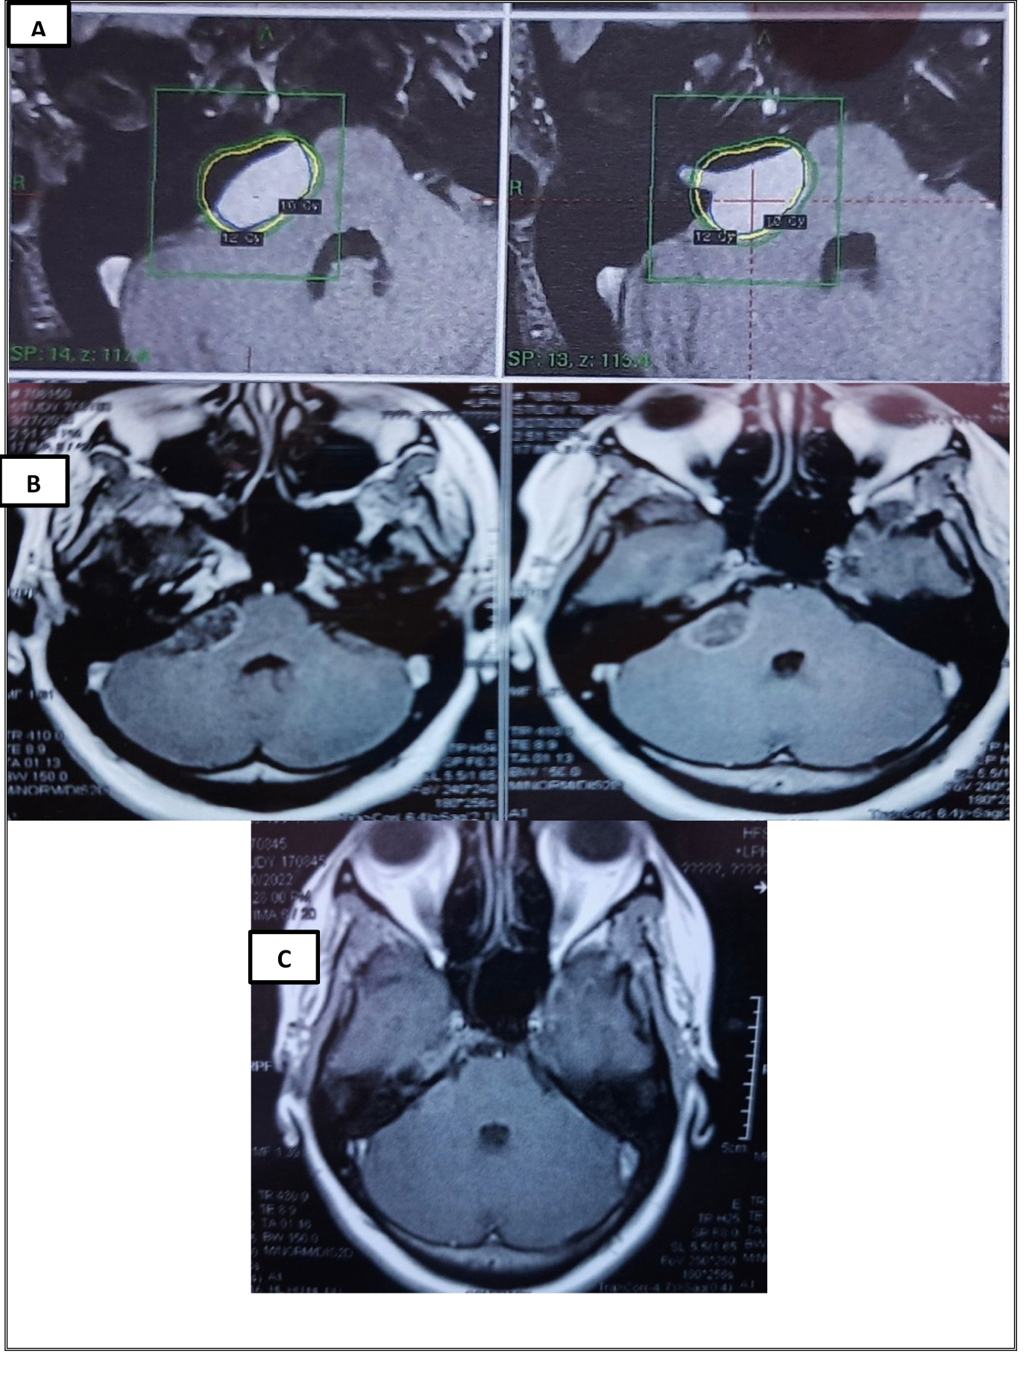Figure 1 as showing: (A) MRI brain T1WI with contrast shows right CPA vestibular schwannoma(gamma plan) (B) T1WI with contrast (1 year follow up )shows decrease in tumor size and decrease in contrast enhancement (C) T1WI with contrast (1.5 years follow up )shows more decrease in size and contrast enhancement.
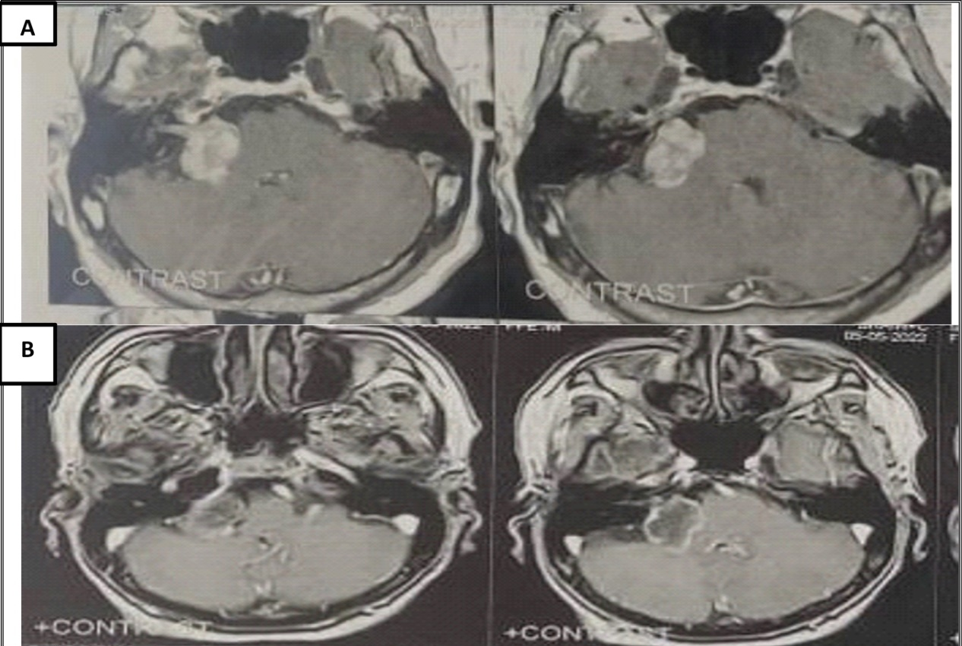
Figure 2 as showing: (A) MRI brain T1WI with contrast shows right CPA vestibular schwannoma (B) T1WI with contrast (1 year follow up) shows decrease in tumor size and decrease in contrast enhancement
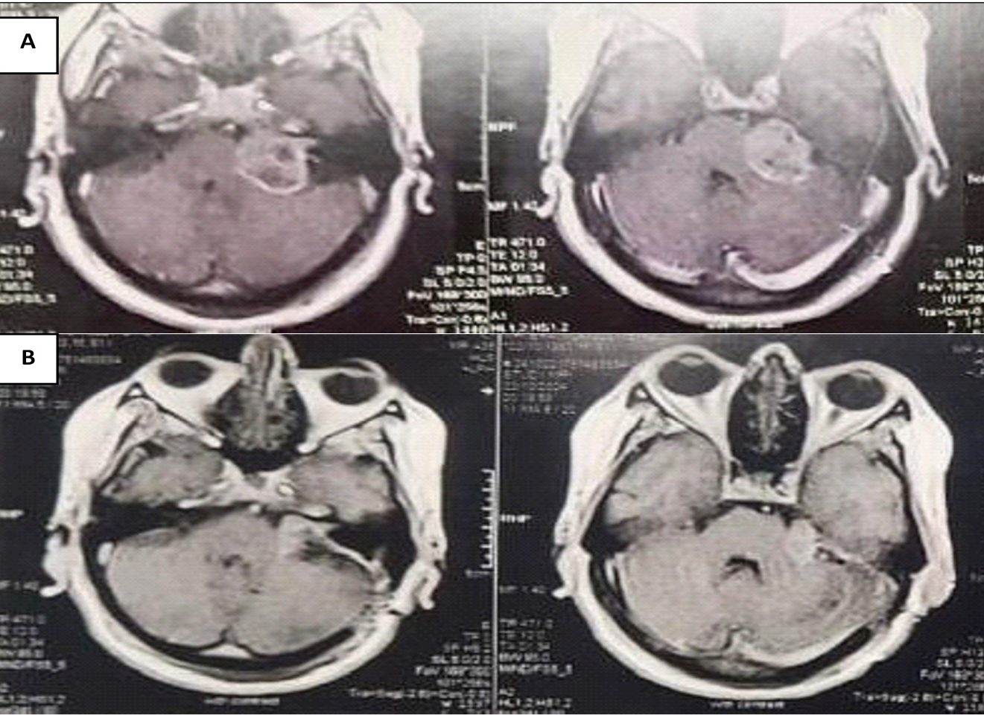
Figure 3 as showing: (A) MRI brain T1WI with contrast shows left CPA vestibular schwannoma. (pre operative) (B) T1WI with contrast (3 months post operative) shows satisfactory reduction of tumor size with decrease compression on brain stem .

